Project Design Phase-II Technology Architecture

|  |  |
| --- | --- |
| Date | 15 October 2022 |
| Team ID | PNT2022TMID02531 |
| Project Name | Project - Inventory Management System for Retailers |
| Maximum Marks | 4 Marks |

Technical Architecture:

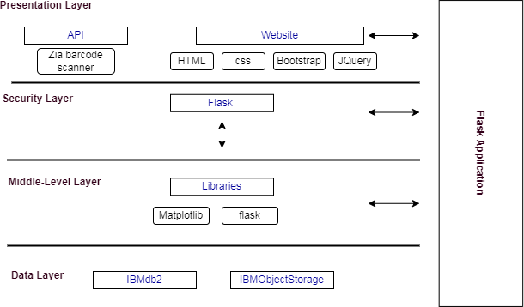

Table-1 : Components & Technologies:

|  |  |  |  |
| --- | --- | --- | --- |
| **S.No** | **Component** | **Description** | **Technology** |
| 1 | User Interface | Web UI with Chatbot | HTML, CSS, Bootstrap, Jquery |
| 2 | Calculating Products Count | By entering barcode details into the application | Zia Barcode Scanner |
| 3 | Showing high demand product | By the products data in IBMdb2 | Data Visualization using Python Bar plot by Matplot Library |
| 4. | Alert and Notification | Alerting the retailers regarding the low stock count of the  product | SendGrid |
| 5 | Chat | Chat with watson assistant | IBM Watson Assistant |
| 6 | Cloud Database | Database Service on Cloud | IBM DB2 |
| 7 | File Storage | File storage requirements | IBM Object Storage |
| 8 | External API-1 Barcode | To Scan the product barcode | Zia Barcode Scanner |
| 9 | Infrastructure (Server / Cloud) | Cloud Server Configuration | Cloud Foundry, Kubernetes |

Table-2: Application Characteristics:

|  |  |  |  |
| --- | --- | --- | --- |
| **S.No** | **Characteristics** | **Description** | **Technology** |
| 1. | Open-Source Frameworks | Styling our page,Python flask microframework | Python Flask, Bootstrap |
| 2. | Security Implementations | For securing our cloud data | SSL Certificates |
| 3. | Scalable Architecture | Three – tier architecture (MVC) | Web server - HTML, CSS, Javascript  Application server - Python Flask, Docker, Container Registry Database server - IBM DB2 |
| 4. | Availability | availability of application | IBM Load Balancer |
| 5. | Performance | 5 requests per seconds,  Use of Local Machine Cache Memory | IBM Cloud, CDN |